Our Favorite Math Websites
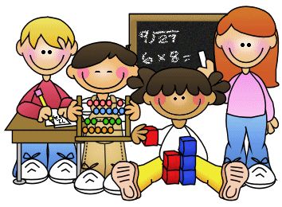

Mega Math (a great resource on the student portal)
http://www.ixl.com/
http://coolmath4kids.com/
http://resources.oswego.org/games/
http://www.mathplayground.com/functionmachine.html
http://www.mathplayground.com/mathvideos.html
http://www.harcourtschool.com/menus/math2004/math2004_menu_ga.html
http://www.multiplication.com/
http://www.fun4thebrain.com/mult.html
http://www.uen.org/3-6interactives/math.shtml
http://www.abcya.com/math_bingo.htm
http://www.arcademicskillbuilders.com/
http://teachers.henrico.k12.va.us/staffdev/clough_d/Flash/RoundingRobot.swf
http://www.kaidy.com/MultFunSample.htm
http://www.e-learningforkids.org/
http://www.abcya.com/

